**Assignment 8**

**Social Network Analysis**

1. HITS Algorithm

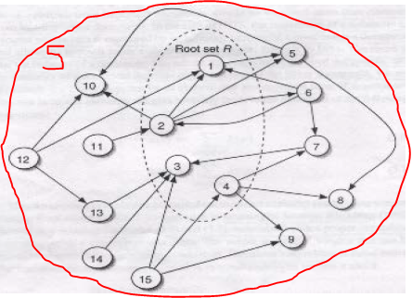

|  |  |  |
| --- | --- | --- |
| **Page** | **Hub Score** | **Authority Score** |
| 1 | 0.121942152 | 0.397359707 |
| 2 | 0.30485538 | 0.264906471 |
| 3 | 0.060971076 | 0.529812943 |
| 4 | 0.365826457 | 0.132453236 |
| 5 | 0.060971076 | 0.264906471 |
| 6 | 0.426797533 | 0.132453236 |
| 7 | 0.243884304 | 0.264906471 |
| 8 | 0.060971076 | 0.264906471 |
| 9 | 0.060971076 | 0.264906471 |
| 10 | 0.060971076 | 0.397359707 |
| 11 | 0.121942152 | 0 |
| 12 | 0.426797533 | 0 |
| 13 | 0.243884304 | 0.132453236 |
| 14 | 0.243884304 | 0 |
| 15 | 0.426797533 | 0 |

1. HITS Algorithm

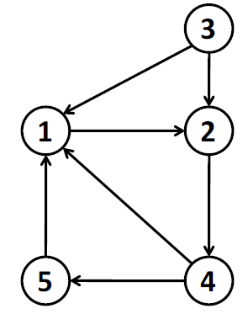

Authority

Hub

|  |  |  |
| --- | --- | --- |
| **Page** | **Hub Score** | **Authority Score** |
| 1 | .26967994 | .774596669 |
| 2 | .13483997 | .516397779 |
| 3 | .67419986 | 0 |
| 4 | .53935989 | .25819889 |
| 5 | .40451992 | .25819889 |

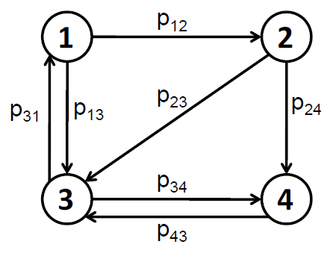

Authority

Hub

|  |  |  |
| --- | --- | --- |
| **Page** | **Hub Score** | **Authority Score** |
| 1 | .52075564 | .25819889 |
| 2 | .65094455 | .25819889 |
| 3 | .39056673 | .774596669 |
| 4 | .39056673 | .516397779 |

The results of both of the above networks do appear to be consistent with hubs and authorities, as the hubs and authorities containing the greatest number out-links and in-links respectively, have the greatest scores respectively.